SG1210W Solar DC Generator
User’s manual

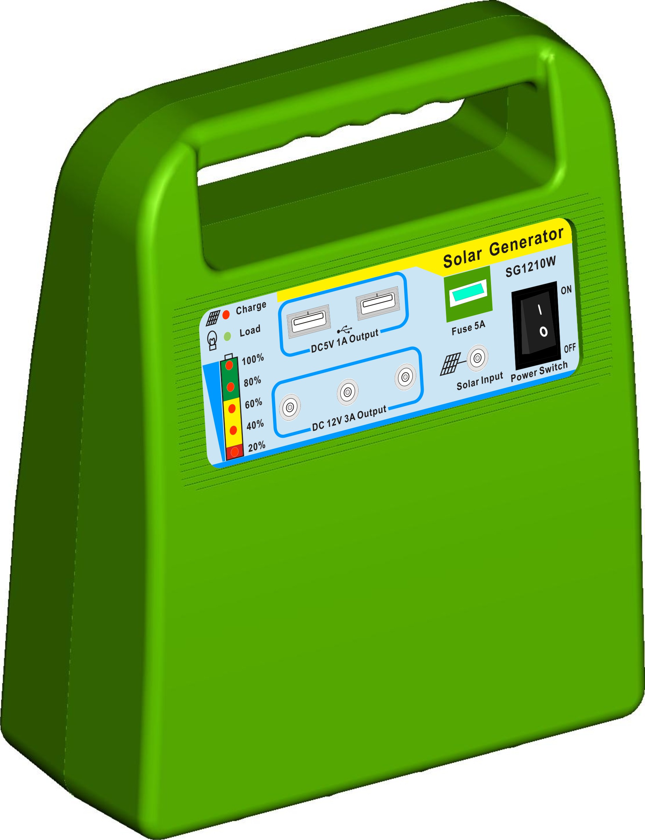
Please read this manual carefully before you use the product
Product Introduction
This is Mini DC solar power system. It can provide power for all kinds of low voltage electrical appliances, such as Automobile electric appliance, DC LED, Mobile phone, digital products. With complete functions, simple operation, no need complex installation, plug and play.
- MCU control (Micro Control Unit), PWM type charging work in with advanced charging and discharging control algorithm, it can effectively prolong the service life of battery.
- Offer DC 12V output interface and 5V USB output interface.
- 5 grade Indicator for Capacity of battery, Indicators for LVD, Charging, Float charging, and Overloading.
- All round Reverse Connected Protection, Reverse Charging Protection, Overcharging Protection, Overload Protection
- It can direct start charging function without turn on the production, so the self-consumption will be low.
- Battery Low final protection, no need to worry about destroyed battery because long time forgetting to close the system.
- Optional MP3 Decoding and Radio.
- Support for multiple color selection, to meet the different needs of customers.
yellow | green | blue | white | red

Safety
- Avoid using the machine under such conditions as having flammable or explosive or erosive gas and too hot places.
- This product supply maximum 30W charge power and maximum 36W discharge power (Max output current for USB port： 1.0A), please check before you use.
- The built-in battery specification is 7AH-12V, attached solar panel 10W-17V. Each day solar panel could generate 3.5AH energy in plenty of sunshine. (Calculated at Max sunshine 6hours) To keep one 3W LED continue working 10hours.(The above parameters is the theoretical value, due to geographical location, use of the environment, use of years, there will be difference)
- This product is a low voltage DC system. Do not use any other unknown charge equipment to charge the machine, so as not to damage the machine.
- The rated voltage of LED is 12V DC which works with this product. Please do not use with other voltage.
- The battery type is Valve regulated Lead Acid Battery, do not upside down, beat, high temperature baking, in order to avoid damage the battery or cause a fire.

Installation and Operation
- Product function diagram
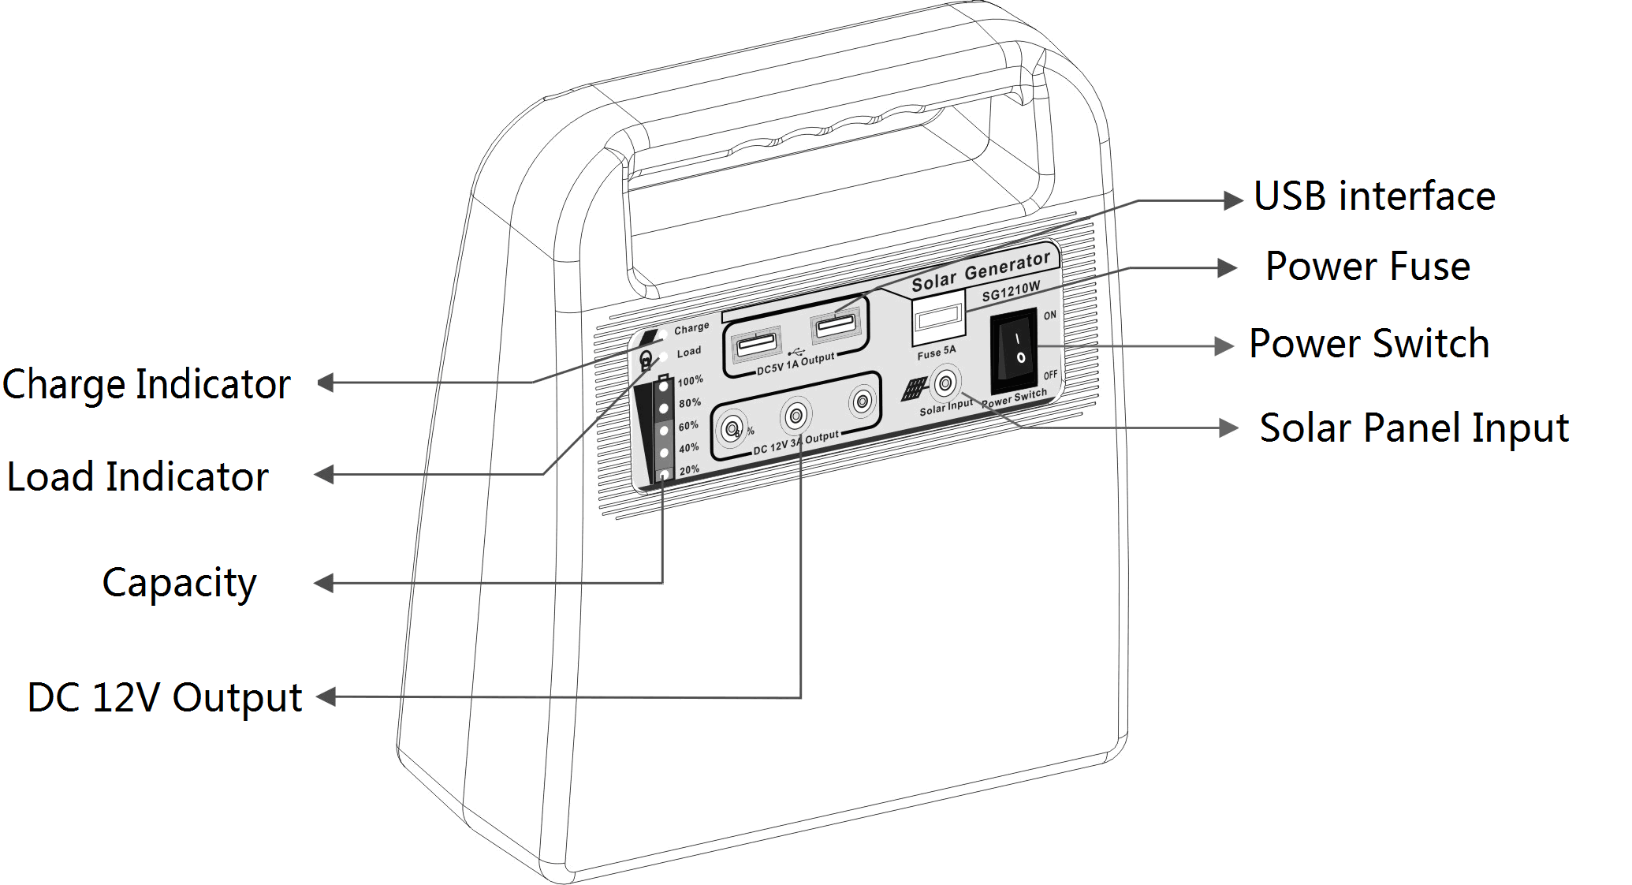
Front panel of the product
- USB interface： Charging for 5V DC equipment such as Mobile phone, Pad, Digital Camera and so on.
- Power Fuse： To prevent short circuit of battery, please take out the fuse if long term no use.
- Power Switch： Control the machine and output of the load.
- Solar Panel Input：Connected with solar panel and AC charge adapter.
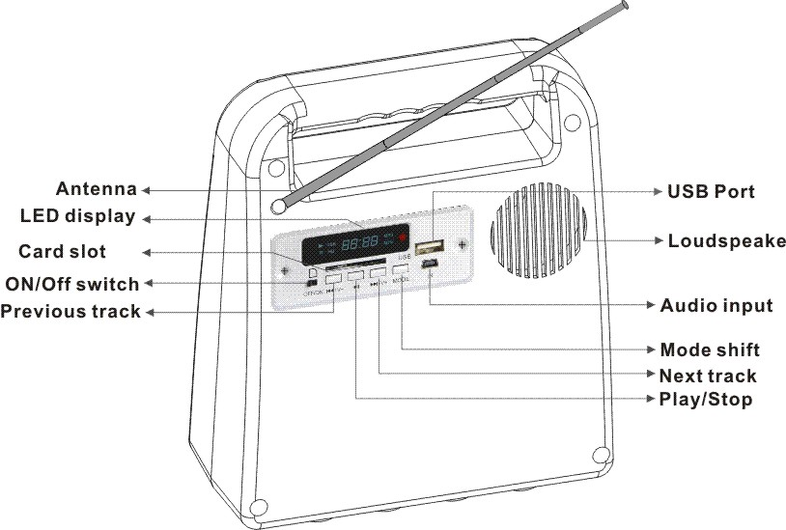
- DC 12V Output：Connected with 12V LED or others 12V equipment.
- Capacity：A real-time indicate the capacity of battery
- Load Indicator：Indicate the working state of load.
- Charge Indicator：Indicate the charging state of battery

Back panel of the product（Note：this back panel exist only when FM function is customized. ）
- USB Port ：Capable of reading MP3 files from USB driver and card reader.
- Loudspeaker： High volume, full frequency and clear sound quality.
- Audio input： Being able to amplifying other audio source when AUX mode is chosen.
- Mode shift： Press this button momentarily to shift among USB, SD, AUX and FM functions.
- Next track： Press this button momentarily to play the next file or enter next frequency channel in USB, SD, AUX and FM states; long press it to amplify Volume.
- Play/Stop：Press this button momentarily to shift between play and stop in USB/SD states; and auto searching and saving FM channels can also be realized by short press this button in FM state.
- Previous track： Press this button momentarily to move to a previous track in USB, SD, AUX and FM states; long press it to decrease volume.
- ON/Off switch： Turn on or turn off the radio.
- Card slot： Being able to read the MP3 files in SD cards.
- LED display：Current working state of the radio will be showed here.
- Antenna：To boost the signal while performing FM function.
- Installation and operation
- Unpack and take out the machine and other accessories to make sure you get the whole suit.
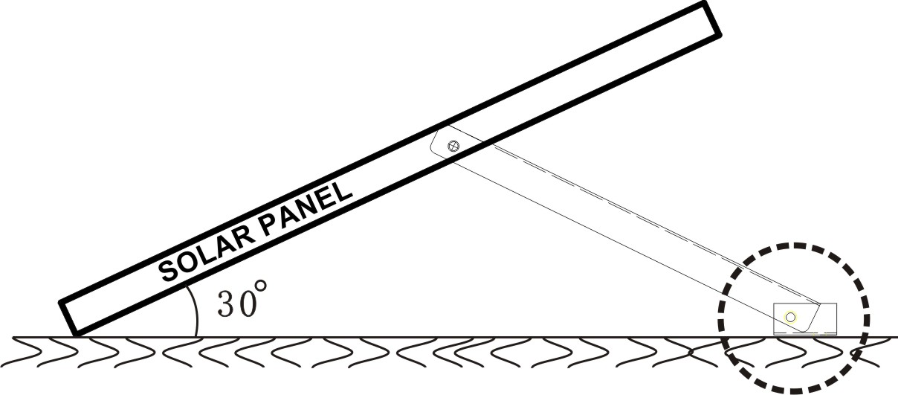
- Solar panel should be put outside sunward. Adjust the holder to create a 30 degrees angle between the holder and the ground (different region with different angles.).Then to fasten the holder with screws

- To introduce the cables of the solar panel into indoor space and to connect them with the input port of the solar machine.
- To insert the fuse into the fuse-holder, otherwise, the product may remains abnormal.
- If there is enough sunshine, the red charging indicator will be lighted, and it indicates the state of charging the battery.
- If the voltage of the battery is more than 14V, the charging indicator will flicker to signify that the battery is full and has entered PWM charging state (if it is the first time you use this product or if you have not used it for a long time, please charge the battery for 10 hours continuously before discharging it).
- This solar machine can protect battery from reverse discharging, please make sure that solar panel is connected to the machine all the time, so that more power can be obtained.
- Turn on the power switch of the machine, the green discharging indicator will be lighted to indicate that the machine can supply power to your loads now.
- To insert LED lamps into DC output ports on the front panel of the machine, the lamps will be lightened; connect your cell phone with USB port to charge your cell phone; to turn on the power switch of the radio on the back panel, MP3 files can be played or FM radio is available.
- To decrease the standby loss of this solar machine, please turn off power switch when no loads are used for a long time.
- When offering the panels and extension cords, we have taken a full consideration of the usage for customers, please do not randomly lengthen or change them. If you do have a reason to adjust or change them, please make sure that the dimension of the solar panel is no less than 0.5mm², and the dimension of the cable for LED lamps no less than 0.3mm². What’s more, all the lead wires have negative and positive polarity, please be sure to notice the distinction.

Operating conditions
indicator | state |  | function
Charging indicator | on |  | solar panel is charging the battery
Charging indicator | flickering |  | battery is full and enter float charge state
Charging indicator | off |  | panel low voltage or no connection  batte
load indicator | on |  | load output port is available
load indicator | flickering |  | overload protection state
load indicator | off |  | load output port is not available
battery level indicator | 100% | on | battery voltage is no lower than 13V
battery level indicator | 100% | off | battery voltage is no higher than12.6V
battery level indicator | 80% | on | battery voltage is no lower than 12.6V
battery level indicator | 80% | off | battery voltage is no higher than 12.4V
battery level indicator | 60% | on | battery voltage is no lower than 12.4V
battery level indicator | 60% | off | battery voltage is no higher than 12.0V
battery level indicator | 40% | on | battery voltage is no lower than 12.0V
battery level indicator | 40% | off | battery voltage is no higher than 11.5V
battery level indicator | 20% | on | battery voltage is no lower than 11.5V
battery level indicator | 20% | flickering | battery voltage is no higher than 11.0V and enter under-voltage protection state
battery level indicator | 20% | off | Power switch is off or voltage is lower than 10.5V and enter standby state
Routing maintenance and common troubleshooting
- Routing maintenance
  - This solar system is for indoor use; please do not let the solar machine get exposure to strong sunlight and damp. If accidentally the machine is filled with water, please turn off the power switch and make sure the machine is dried before reuse it.
  - If you are not going to use it frequently, please turn off the power switch and charge he battery until it is full once a month.
  - The battery capacity is 7AH, in order to guarantee the service time for battery, please try to keep the charge and discharge current within 1/5C
  - Please avoid keeping the battery under-voltage for a long time, otherwise, the capacity and service life of the battery will be affected. Every time when the battery is under-voltage, you’d batter charge it for two days or more before reuse it.
- Common troubleshooting
- Charging indicator is off： Please check whether the solar panel is sunwards or battery is full. Make sure the connecting cables are connected in the right way.
- Output is not available and the load indicator is off： Please check whether there are only three indicators for battery levels are lighted; whether the system has entered battery under-voltage protection state; whether the power switch of the machine is turned on. If the battery is under-voltage, please charge it continuously for 10 hours before reuse it.
- Output is not available and the indicators for battery level are flickering： Battery is under-voltage, please wait to reach the recovery point or restart to normal working state.
- Output is not available and the load indicator is flickering： Please check whether it is overload or short circuit, remove the loads then wait for 2 minutes or restart the power switch.
- All the indicators are off and no output for the loads： Please check whether the power switch is turned on, and whether the machine is over-discharge and enter standby state.
- Radio function is not available： Please check whether the power switch for the radio is turned on and you have chosen the right mode; check whether you have to searching for FM channels and save them.
- The machine has no any reaction and neither charge nor discharge is available： Please check whether the fuse is inserted into the fuse holder rightly and whether the fuse has been blown up.
Technical data
Model  parameter | SG1210W |  | SG1210W-M
Input charging voltage | solar panel ≤25V or AC charger 15-16V
Max. charging current | 2A |  | 2A
Rated output current | 3A |  | 3A
Current value for overload protection | 4A
Current value for short circuit protection | 2.2 times of rated current
Time for restart | Automatic release after 30S or turn off the power switch directly
Output current for USB | 1A
over-discharge protection | 11.0V
over voltage recovery | 12.6V
Voltage for float charge | 13.8V
Over voltage value for protection | 15.5V
Charging mode | PWM available
Audio format available | --- | MP3
Frequency range of the radio | --- | FM 88—108MHZ
Power of loud speaker | --- | 4Ω--3W
Input port | --- | SD card, USB
Working temperature | -25℃----+60℃
Dimension | 180*81*209(mm)
Net weight | 2.55Kg

